To view the flowchart and diagram: Click the below link
https://mermaidviewer.com/share/CDmWOLcQSn57OiqiIfdMf

Sample Screenshot:
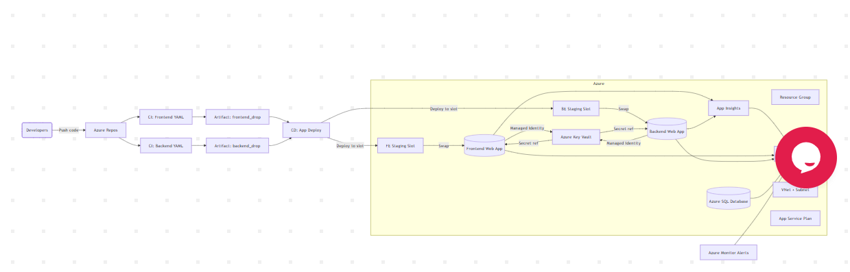

Flowchart CMD:
%%{init: {'theme':'default'}}%%
flowchart LR
Dev(Developers) -->|Push code| AzureRepos[Azure Repos]
AzureRepos --> CI_FE[CI: Frontend YAML]
AzureRepos --> CI_BE[CI: Backend YAML]
CI_FE --> Artifacts_FE[Artifact: frontend_drop]
CI_BE --> Artifacts_BE[Artifact: backend_drop]
Artifacts_FE --> CD_App[CD: App Deploy]
Artifacts_BE --> CD_App

subgraph Azure[Azure]
RG[Resource Group]
KV[Azure Key Vault]
LAW[Log Analytics]
AI[App Insights]
VNet[VNet + Subnet]
ASP[App Service Plan]
FE[(Frontend Web App)]
FE_S[FE Staging Slot]
BE[(Backend Web App)]
BE_S[BE Staging Slot]
SQL[(Azure SQL Database)]
end

CD_App -->|Deploy to slot| FE_S
CD_App -->|Deploy to slot| BE_S
FE_S -->|Swap| FE
BE_S -->|Swap| BE

FE -->|Managed Identity| KV
BE -->|Managed Identity| KV
KV -->|Secret ref| FE
KV -->|Secret ref| BE
AI --> LAW
FE --> AI
BE --> AI
FE --> LAW
BE --> LAW
SQL --> LAW

Monitor[Azure Monitor Alerts] --> LAW

